**-: Assignment :-**

**Interactive Application:**

An interactive application is one where the user actively interacts with the software while it's running.

**Examples:**

* Command-line tools that ask for input.
* Chat applications like WhatsApp.
* GUIs where you click buttons, enter text, and see live results.

**Key Features:**

* Takes user input during runtime.
* Waits for user response.
* Real-time interaction.

**Examples:**

**Application Type Why it’s Interactive**

PowerShell (when typed manually) Interactive type and get responses immediately

Web browser Interactive click, scroll, type

Game software Interactive Controlled by user input

**Non-Interactive Application:**

A non-interactive application runs automatically without user input during execution.

**Key Features:**

* Executes tasks without waiting for user interaction.
* Often used in automation, background processes, or scripts.

**Examples:**

**Application Type Why it’s Non-Interactive**

Scheduled PowerShell script Non-Interactive Runs automatically via Task Scheduler

Backup software running overnight Non-Interactive No human needed during execution

|  |
| --- |
|  |

In the image the I open the task manager ,It shows us Interactive apps as Apps(like Goolgle chrome,

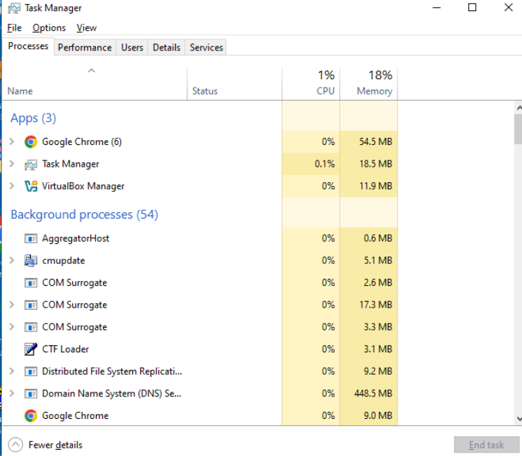VirtualBox manager,etc) and Non-interactive apps as in Background Processes(like AggregatorHost,cmupdate,etc.).

**What is Company Portal ?**

The Company Portal is an app provided by Microsoft that allows users to securely access corporate resources like:

* Company apps (assigned by IT)
* Wi-Fi & VPN settings
* Device enrollment
* Compliance status of device
* Helpdesk contact info

Installation :- Just click on the downloaded file - Company Portal Installer.exe then this window

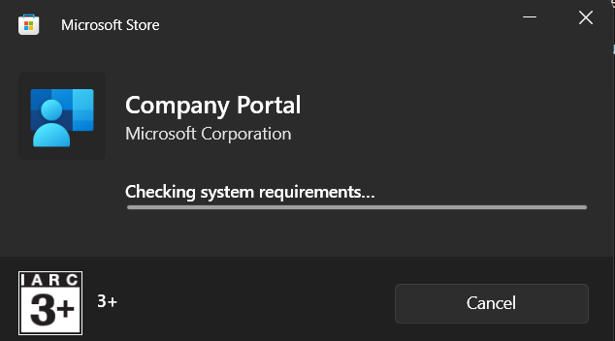Opens:-

Now login by your business mail id or intune mail id:-

